SOFTWARE TESTING REPORT
Quality Assurance & Test Engineering Documentation
Enterprise Governance, Risk, Compliance & Procurement Platform (e-GRCP)

Project Name | Enterprise Governance, Risk, Compliance & Procurement Platform (e-GRCP)
Application Type | Enterprise React Frontend Application
Developer | Nischay Suman Achar
Technology Stack | React 19, Vite, Redux Toolkit, Redux Persist, React Router DOM, Axios, React Hook Form, Yup, Material UI, Recharts
Testing Framework | Jest & React Testing Library
Deployment Target | Vercel
Report Date | July 5, 2026

Table of Contents

1. Introduction 3
2. Testing Strategy 4
3. Testing Environment 5
4. Testing Tools 5
5. Modules Tested 6
6. Test Scenarios 9
7. Sample Test Cases 11
8. Testing Methodology 14
9. Code Coverage 15
10. Error Handling Validation 15
11. Performance Testing 16
12. Challenges Faced During Testing 17
13. Bug Summary 18
14. Results 19
15. Conclusion 20

1. Introduction

1.1 Purpose of Testing
This document presents the Software Testing Report for the Enterprise Governance, Risk, Compliance & Procurement Platform (e-GRCP). The report describes the test planning approach, execution methodology, coverage achieved, and quality outcomes for the frontend application in its current stage of development.
The report is scoped strictly to functionality that has been implemented and verified as of the current build. Capabilities that are planned but not yet implemented are identified separately as future work and are not represented as tested.

1.2 Objectives
- Validate that the Authentication module and Executive Dashboard behave correctly against their implemented requirements.
- Verify the correctness of state management operations implemented through Redux Toolkit, specifically the Auth Slice and Dashboard Slice, including reducers, actions, and asynchronous thunks.
- Confirm that Protected Routes, Public Routes, and Role Based Routes behave in accordance with the routing configuration implemented via React Router DOM.
- Ensure form validation logic implemented through React Hook Form and Yup schemas correctly enforces data entry rules on the Login and related authentication forms.
- Assess the behavior of the centralized Axios service layer against mock JSON API responses, including simulated error conditions.
- Establish a quantified measure of code coverage using Jest and React Testing Library.
- Identify, log, and track defects observed during development and testing, and confirm resolution through re-testing.

1.3 Scope
The scope of this testing engagement covers the Authentication module, the Executive Dashboard module, shared/common components (FormInput, PasswordInput, Loader, Header, Sidebar), the Redux Toolkit state layer, application routing, the Axios service layer, and the global Error Boundary. All backend interaction is currently served through mock JSON data; no live backend, database, or external API is integrated at this stage, and testing of such integrations is therefore outside the scope of this report.
Additional business modules referenced in the platform's long-term roadmap — including Procurement, Vendor Governance, Risk Center, Compliance Center, Audit Center, Approval Workbench, Notification Center, and Reporting Center — are not yet implemented. Redux Toolkit has slices prepared in anticipation of these modules, but no functional UI, business logic, or test coverage exists for them at this time. These are noted as future work in Section 12 and are excluded from this report's scope.

1.4 Importance of Software Testing
Establishing disciplined testing practices early in an enterprise frontend project reduces the cost of defect resolution as the application grows in scope. For e-GRCP, where authentication and routing form the security foundation upon which future governance and compliance modules will be built, verifying these layers thoroughly at this stage is of particular importance, since defects in access control or state persistence would propagate into every module built on top of them.

2. Testing Strategy
The testing strategy for e-GRCP follows a layered approach appropriate to the current scope of the application, combining unit tests for isolated logic, component tests for UI behavior, and manual verification of end-to-end flows within the implemented Authentication and Dashboard modules.

2.1 Unit Testing
Unit testing was performed on isolated functions and Redux Toolkit logic using Jest, including reducer functions within the Auth Slice and Dashboard Slice, and the Yup validation schemas used by the Login and Reset Password forms.

2.2 Component Testing
Component-level tests were implemented using React Testing Library for the common/shared components: FormInput, PasswordInput, Loader, Header, and Sidebar, along with the Authentication and Dashboard screens. Tests assert rendered output and behavior in response to simulated user events such as typing, clicking, and toggling password visibility.

2.3 Redux Testing
The Auth Slice and Dashboard Slice were tested independently of the React component tree. Reducer functions were tested for correct state transitions given specific action payloads, and the createAsyncThunk used for mock authentication was tested to validate pending, fulfilled, and rejected lifecycle states. Redux Persist configuration was validated to confirm that the Auth Slice is correctly rehydrated on application reload.

2.4 Routing Testing
React Router DOM configuration was tested to confirm correct rendering of route components, redirect behavior for unauthenticated users attempting to access Protected Routes, correct enforcement of Role Based Routes, and fallback behavior for unmatched paths via the 404 page.

2.5 Form Validation Testing
The Login form, built with React Hook Form and validated through Yup, was tested for required field enforcement, email format validation, and password field behavior, including the show/hide password toggle implemented in the PasswordInput component.

2.6 Service Testing
The Axios service layer was tested against the mock JSON data source to confirm correct request handling and correct propagation of simulated error responses to calling components.

2.7 Manual Testing
Manual exploratory testing was performed across the Authentication and Dashboard modules to verify visual layout, navigation behavior, and behavior under manual browser refresh, including the 404-on-refresh condition encountered on Vercel deployment.

2.8 Regression Testing
Following each defect resolution recorded in Section 13, the associated automated test suite was re-executed to confirm that the fix did not introduce new defects in related functionality.

3. Testing Environment
All automated and manual testing activities described in this report were executed within the following environment configuration.
Environment Parameter | Specification
Operating System | Windows 11
Node.js Version | 24.11.1
Package Manager | npm
IDE | Visual Studio Code
React Version | React 19
Build Tool | Vite
Unit / Component Testing Framework | Jest with React Testing Library
Version Control | Git / GitHub
Deployment Target | Vercel

4. Testing Tools

4.1 React Testing Library
Used as the primary tool for rendering components in a simulated DOM (jsdom) and asserting on rendered output using accessibility-oriented queries.

4.2 Jest
Used as the test runner, assertion library, and mocking framework across the test suite, including mocking of the Axios service layer and browser storage APIs used by Redux Persist.

4.3 Redux Toolkit Testing
The Auth Slice and Dashboard Slice were tested using isolated store instances created per test case, allowing each slice to be exercised against controlled initial state.

4.4 Mock JSON Data
A mock JSON data source was used to simulate authentication responses and dashboard data, allowing deterministic testing of success and failure scenarios without a live backend.

4.5 Browser Developer Tools
Chrome DevTools and the React Developer Tools browser extension were used during manual testing to inspect component hierarchies, Redux state (via Redux DevTools), and console output.

4.6 Coverage Reports
Jest's built-in coverage reporter (Istanbul) was used to generate statement, branch, function, and line coverage metrics for the implemented codebase.

5. Modules Tested
The following table enumerates the modules and functional areas of the current e-GRCP build that were within scope of this testing cycle.
Module / Area | Key Capabilities Verified
Authentication Module | Login, Forgot Password, Reset Password, Session Expired, Access Denied, 404 Page
Executive Dashboard | Dashboard rendering and data display using mock JSON data
Common / Shared Components | FormInput, PasswordInput, Loader, Header, Sidebar
State Management (Redux Toolkit) | Auth Slice, Dashboard Slice, Redux Persist rehydration
Routing | Protected Routes, Public Routes, Role Based Routes, 404 fallback
Service Layer | Centralized Axios service layer against mock JSON APIs
Error Handling | React Error Boundary, validation, network, and API error handling

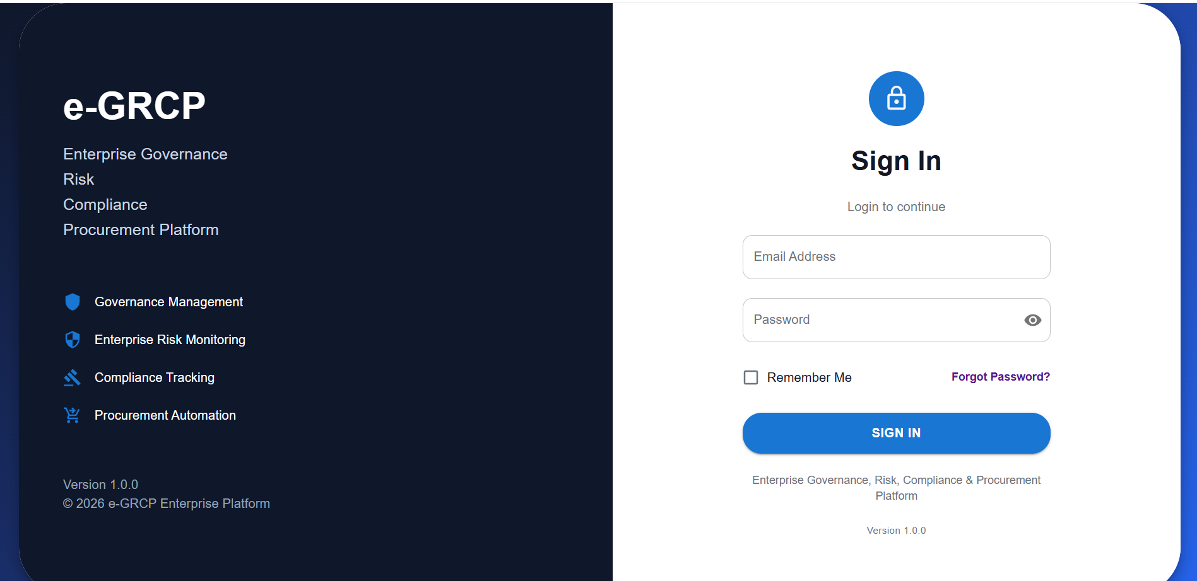
Figure 5.1: Login Screen

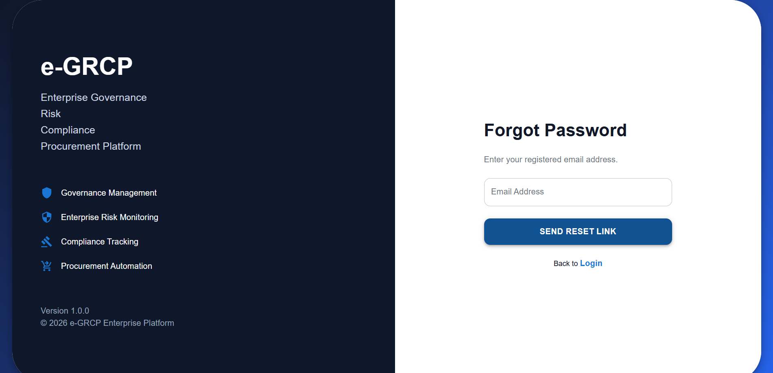
Figure 5.2: Forgot Password Screen

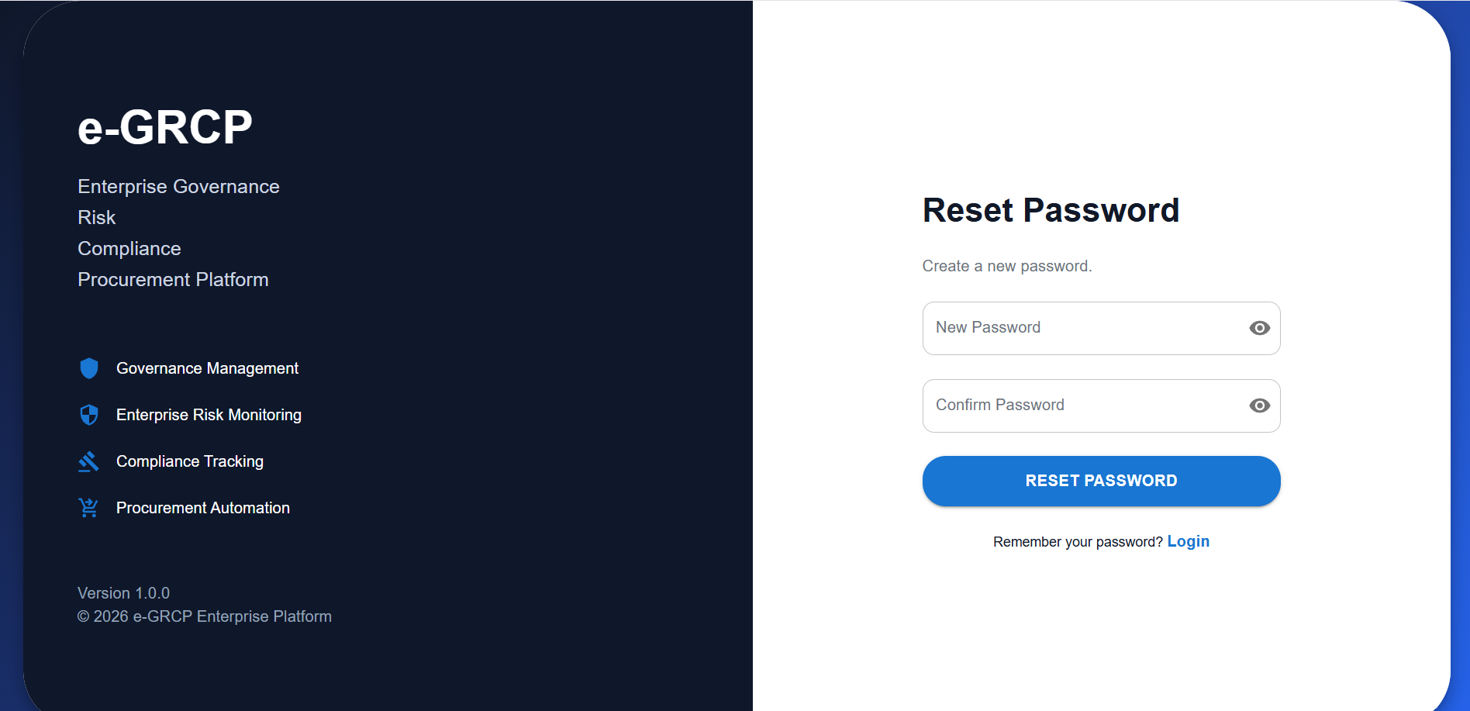
Figure 5.3: Reset Password Screen

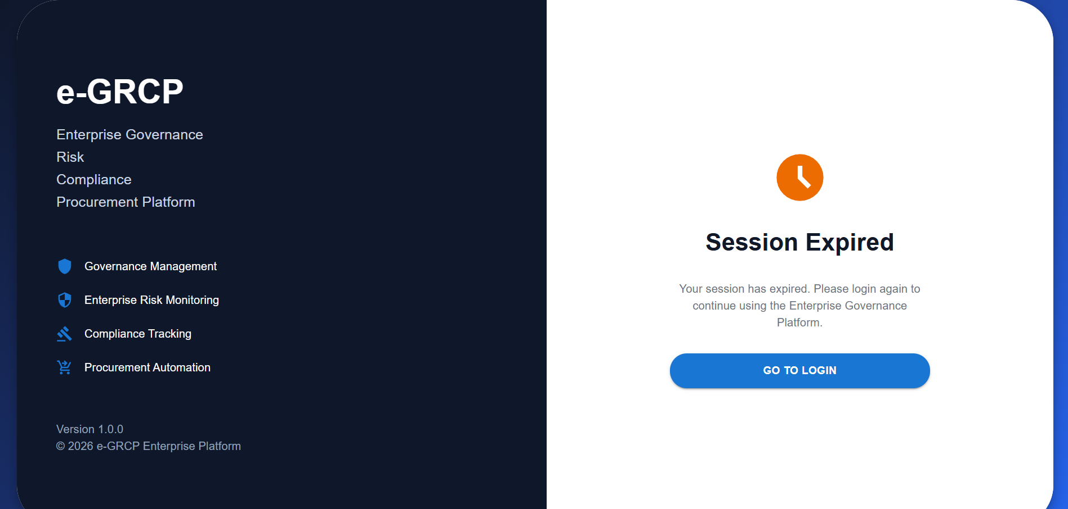
Figure 5.4: Session Expired Screen
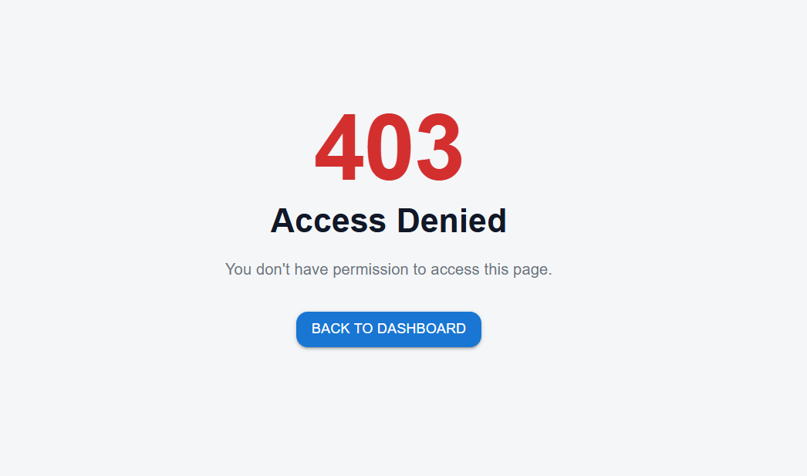
Figure 5.5: Access Denied Screen
Business-domain modules such as Procurement, Vendor Governance, Risk Center, Compliance Center, Audit Center, Approval Workbench, Notification Center, and Reporting Center are not implemented in the current build and are therefore not included in this table. Redux Toolkit includes slice scaffolding prepared for some of these modules, but no associated UI or logic exists yet to test.

6. Test Scenarios
Test scenarios were derived from the implemented functionality described in Section 5. The scenarios below represent the conditions exercised during automated and manual test execution.

6.1 Authentication
- Successful login with valid mock credentials
- Login attempt with invalid credentials
- Logout and session/state clearing
- Forgot Password request flow
- Reset Password form submission
- Session Expired page display on expired session state
- Access Denied page display for unauthorized route access
- 404 Page display for unmatched routes

6.2 Routing
- Protected Route redirect for unauthenticated users
- Public Route accessibility without authentication
- Role Based Route resolution for permitted and non-permitted roles

6.3 Redux State Management
- Redux store creation and initial state validation
- Auth Slice reducer state transitions
- Dashboard Slice reducer state transitions
- createAsyncThunk pending, fulfilled, and rejected states for mock authentication
- Redux Persist rehydration of the Auth Slice on application reload

6.4 Service Layer
- Axios request against mock JSON API with successful response
- Axios request against mock JSON API with simulated error response

6.5 Form Validation
- Required field validation on the Login form
- Email format validation via Yup schema
- Password field validation via Yup schema

6.6 Common Components
- Loader visibility during pending asynchronous operations
- Sidebar navigation link rendering and click behavior
- Header rendering and session-aware content display
- FormInput rendering, value binding, and error message display
- PasswordInput show/hide toggle behavior

6.7 Error Boundary
- Error Boundary fallback rendering on a simulated component exception

7. Sample Test Cases
The table below presents the test case suite executed against the currently implemented modules of the e-GRCP frontend application. Each test case is uniquely identified, mapped to its owning module and scenario, and recorded with input conditions, expected results, observed actual results, and final execution status.
Test ID | Module | Scenario | Input | Expected Result | Actual Result | Status
TC-001 | Authentication | Successful login | Valid mock email + valid password | User authenticated; redirected to Dashboard | User authenticated; redirected to Dashboard | Pass
TC-002 | Authentication | Invalid login | Valid email + incorrect password | Error message displayed; login blocked | Error message displayed; login blocked | Pass
TC-003 | Authentication | Empty credentials submission | Blank email and password fields | Required field validation errors shown | Required field validation errors shown | Pass
TC-004 | Authentication | Logout | Authenticated user clicks Logout | Auth state cleared; redirected to Login page | Auth state cleared; redirected to Login page | Pass
TC-005 | Authentication | Forgot Password navigation | User clicks 'Forgot Password' link | Forgot Password form rendered | Forgot Password form rendered | Pass
TC-006 | Authentication | Forgot Password submission | Valid mock email submitted | Confirmation message displayed | Confirmation message displayed | Pass
TC-007 | Authentication | Reset Password form submission | New password meeting Yup complexity rule | Success message displayed; redirected to Login | Success message displayed; redirected to Login | Pass
TC-008 | Authentication | Reset Password validation | New password below complexity rule | Validation error displayed; submission blocked | Validation error displayed; submission blocked | Pass
TC-009 | Authentication | Session Expired display | Simulated expired session state | Session Expired page rendered | Session Expired page rendered | Pass
TC-010 | Authentication | Access Denied display | User without required role accesses restricted route | Access Denied page rendered | Access Denied page rendered | Pass
TC-011 | Authentication | 404 Page display | Navigation to an undefined route | 404 Page rendered | 404 Page rendered | Pass
TC-012 | Routing | Protected Route redirect | Unauthenticated user requests a protected path | Redirected to Login page | Redirected to Login page | Pass
TC-013 | Routing | Protected Route access when authenticated | Authenticated user requests a protected path | Requested route rendered without redirect | Requested route rendered without redirect | Pass
TC-014 | Routing | Public Route access | Unauthenticated user requests the Login route | Login page rendered without redirect | Login page rendered without redirect | Pass
TC-015 | Routing | Role Based Route — permitted role | User with permitted role requests role-restricted route | Route rendered normally | Route rendered normally | Pass
TC-016 | Routing | Role Based Route — non-permitted role | User without permitted role requests role-restricted route | Access Denied page rendered | Access Denied page rendered | Pass
TC-017 | Redux Store | Store initialization | Application bootstrap | Root reducer initializes with defined default state | Root reducer initializes with defined default state | Pass
TC-018 | Redux Store | Auth Slice reducer transition | Dispatch setUser action with mock payload | State.auth.user updated to payload value | State.auth.user updated to payload value | Pass
TC-019 | Redux Store | Dashboard Slice reducer transition | Dispatch setDashboardData action with mock payload | State.dashboard.data updated to payload value | State.dashboard.data updated to payload value | Pass
TC-020 | Redux Store | createAsyncThunk pending state | Login thunk dispatched | loading flag set to true | loading flag set to true | Pass
TC-021 | Redux Store | createAsyncThunk fulfilled state | Login thunk resolves with mock user data | loading false; user state populated | loading false; user state populated | Pass
TC-022 | Redux Store | createAsyncThunk rejected state | Login thunk mock rejects with error | loading false; error message set in state | loading false; error message set in state | Pass
TC-023 | Redux Persist | State rehydration | Application reload with persisted Auth Slice | Auth state restored without requiring re-login | Auth state restored without requiring re-login | Pass
TC-024 | Redux Persist | storage.getItem() failure handling | Mocked storage.getItem() throws an exception | Application falls back to default state without crashing | Application falls back to default state without crashing | Pass
TC-025 | Redux Persist | storage.setItem() failure handling | Mocked storage.setItem() throws an exception | Application continues to function; error logged | Application continues to function; error logged | Pass
TC-026 | Service Layer | Axios mock API success response | Mock login request with valid credentials | Response resolved with expected mock payload shape | Response resolved with expected mock payload shape | Pass
TC-027 | Service Layer | Axios mock API error response | Mock request configured to simulate failure | Error propagated to calling component for handling | Error propagated to calling component for handling | Pass
TC-028 | Form Validation | Login required field validation | Submit Login form with blank fields | Field-level required error messages displayed | Field-level required error messages displayed | Pass
TC-029 | Form Validation | Email format validation | Email input value: 'user@@test' | Invalid email format error displayed | Invalid email format error displayed | Pass
TC-030 | Form Validation | Password complexity validation | Password input value below Yup complexity rule | Password complexity error displayed | Password complexity error displayed | Pass
TC-031 | Common Components | Loader visibility | Asynchronous login request in pending state | Loader component rendered during pending state | Loader component rendered during pending state | Pass
TC-032 | Common Components | Sidebar navigation rendering | Authenticated user views layout | Sidebar renders navigation links for available modules | Sidebar renders navigation links for available modules | Pass
TC-033 | Common Components | Header session-aware rendering | Authenticated user views layout | Header displays authenticated user context | Header displays authenticated user context | Pass
TC-034 | Common Components | FormInput error display | FormInput bound to a field with a validation error | Error message rendered beneath the input | Error message rendered beneath the input | Pass
TC-035 | Common Components | PasswordInput visibility toggle | User clicks the show/hide icon in PasswordInput | Password field toggles between masked and visible text | Password field toggles between masked and visible text | Pass
TC-036 | Error Boundary | Component render failure | Simulated runtime exception in a child component | Error Boundary fallback UI displayed instead of a blank screen | Error Boundary fallback UI displayed instead of a blank screen | Pass
TC-037 | Dashboard | Dashboard initial render | Authenticated user navigates to Dashboard | Dashboard renders using mock JSON dashboard data | Dashboard renders using mock JSON dashboard data | Pass
TC-038 | Deployment | Direct URL refresh on Vercel | Browser refresh on a nested client-side route | Route resolves correctly without a 404 response | Initially returned a 404 (see BUG-104); resolved after fix | Resolved

A total of 38 test cases are reflected above, covering the Authentication module, routing configuration, Redux state management, the service layer, form validation, common components, and error handling. All test cases concluded with a Pass or Resolved status following defect resolution and regression re-testing; TC-038 initially failed due to BUG-104 and is now confirmed resolved (see Section 13).

8. Testing Methodology

8.1 Black Box Testing
Black box techniques were applied to validate observable application behavior for the Login, Forgot Password, Reset Password, and routing flows, without reference to internal implementation.

8.2 White Box Testing
White box techniques were applied at the unit level to exercise internal logic paths within Redux reducers and the createAsyncThunk lifecycle used for mock authentication, confirming code-level correctness of conditional branches.

8.3 Functional Testing
Functional testing verified that the Authentication module and Executive Dashboard perform their intended behavior correctly against the mock data source.

8.4 UI Testing
UI testing confirmed correct rendering of Material UI components used within the Authentication and Dashboard screens, and correct behavior of the FormInput and PasswordInput components.

8.5 Smoke Testing
A smoke test covering login and navigation to the Dashboard was executed against each build prior to proceeding with the full test suite, in order to quickly identify build-breaking defects.

8.6 Regression Testing
Regression testing was executed after each defect fix listed in Section 13, re-running the relevant automated tests to confirm that the fix did not introduce new defects.

8.7 Positive Testing
Positive test cases validated expected system behavior under valid, well-formed input conditions, such as a correctly formatted login submission.

8.8 Negative Testing
Negative test cases validated system behavior under invalid input and unauthorized access attempts, such as an incorrect password or a role-restricted route request, confirming that the application responds with an appropriate message rather than an unhandled error.

9. Code Coverage
Code coverage was measured using Jest's integrated Istanbul instrumentation across the unit, component, and Redux test suites implemented for the current build. Overall coverage across statements, branches, functions, and lines is approximately 95% for the codebase currently in scope.
Metric | Statements | Branches | Functions | Lines
Overall Project Coverage | ~95% | ~95% | ~95% | ~95%

9.1 Coverage by Area
Rather than reporting invented module-level percentages, coverage is discussed qualitatively by functional area based on the depth of test cases implemented for each:
- Authentication: Coverage is high, as the module was tested comprehensively across login, password recovery, session handling, and access-control display states, given its role as the security foundation of the application.
- Redux (Auth Slice and Dashboard Slice): Coverage is high, with reducers and the createAsyncThunk lifecycle exercised across pending, fulfilled, and rejected states.
- Routes: Coverage is high, with Protected, Public, and Role Based Route logic exercised for both permitted and denied conditions.
- Components (FormInput, PasswordInput, Loader, Header, Sidebar): Coverage is strong for rendering and interaction behavior; minor edge cases in responsive layout are covered primarily through manual testing rather than automated assertions.
- Services (Axios layer against mock JSON APIs): Coverage is solid for both success and simulated error paths, though it is inherently bounded by the fact that no live backend integration currently exists to test against.

9.2 Significance of Coverage
Code coverage is not, in isolation, a guarantee of correctness. It is used within this project as an indicator of verification thoroughness across the implemented codebase, in conjunction with — not as a substitute for — the functional test case review presented in Section 7.

10. Error Handling Validation

10.1 React Error Boundary
A global Error Boundary component wraps the application's route tree, catching unhandled rendering exceptions and displaying a fallback interface rather than a blank or crashed screen. This was validated by injecting a rendering exception into a test component and confirming correct fallback rendering.

10.2 Validation Errors
Form-level validation errors, generated via Yup schema evaluation on the Login and Reset Password forms, were confirmed to render correctly beneath their associated fields and to clear once the underlying validation condition is resolved.

10.3 Network Errors
Simulated network failure conditions against the mock Axios service layer were confirmed to be handled without producing an unhandled promise rejection, surfacing an appropriate message to the user instead.

10.4 API Errors
Simulated error responses from the mock JSON API were confirmed to be handled by the service layer and surfaced to calling components in a consistent, predictable shape.

10.5 404 Page
Navigation to undefined application routes was confirmed to resolve to the 404 page during in-app client-side navigation. A related issue affecting direct browser refresh on nested routes under Vercel deployment is documented in Section 13 (BUG-104).

10.6 Access Denied
Attempts by an authenticated user to access a route outside their assigned role were confirmed to resolve to a dedicated Access Denied page, distinct from the 404 page.

11. Performance Testing
Performance verification for the current build focused on confirming correct use of the React optimization patterns actually applied within the codebase. Full-scale load testing and large-dataset performance testing are not applicable at this stage, as the application currently operates against a small, static mock JSON data source rather than production-scale data volumes.

11.1 React.memo
Presentational components subject to frequent parent re-renders were confirmed to be wrapped in React.memo where applied, and were verified to skip re-rendering when their props remain referentially unchanged.

11.2 useMemo
Derived values computed from Redux state were confirmed to be memoized via useMemo where applied, avoiding redundant recalculation on unrelated re-renders.

11.3 useCallback
Event handler functions passed as props to child components were confirmed to be wrapped in useCallback where applied, preserving referential stability.

11.4 Lazy Loading and Code Splitting
Route-level components were confirmed to be lazily loaded via React.lazy, deferring their bundle download until the corresponding route is first navigated to.

11.5 Dynamic Imports
Vite's native support for dynamic import() statements was leveraged for route-level code splitting, consistent with the Lazy Loading behavior described above.

12. Challenges Faced During Testing

12.1 Redux Persist Configuration Issue
Initial Redux Persist configuration produced inconsistent state rehydration in the Jest test environment, where the default storage engine is not available. This was resolved by mocking the storage engine used by Redux Persist within the test environment, ensuring deterministic rehydration behavior across test runs.

12.2 storage.getItem() Error
An unhandled exception occurred when storage.getItem() was called in a test or browser context where storage access was restricted. Error handling was added around the storage access calls used by Redux Persist to prevent the application from crashing under this condition.

12.3 storage.setItem() Error
A similar issue was observed with storage.setItem() under restricted storage conditions. The same defensive error handling approach was applied, and a dedicated test case (TC-025) was added to confirm graceful handling.

12.4 Protected Route Implementation
Implementing and testing the ProtectedRoute component required careful handling of the authentication state check prior to route render, as premature evaluation of Redux state produced incorrect redirect behavior in early implementations. This was resolved by ensuring the ProtectedRoute component waits for the persisted Auth Slice to finish rehydrating before evaluating access.

12.5 Role Based Routing
Early implementation of the RoleBasedRoute component did not correctly distinguish between an unauthenticated user (who should be redirected to Login) and an authenticated user without the required role (who should see the Access Denied page). The routing logic was corrected to check authentication and role authorization as two distinct conditions.

12.6 404 Refresh Issue on Vercel
Directly refreshing the browser on a nested client-side route resulted in a 404 response from Vercel's static hosting, since the underlying request was not being rewritten to the single-page application's entry point. This is tracked as BUG-104 in Section 13.

12.7 Authentication Flow
Coordinating the Login form, the createAsyncThunk-based mock authentication call, and the resulting Redux state update required iteration to avoid a brief flash of unauthenticated UI before redirect. Loading state was introduced to bridge this transition.

12.8 React Hook Form Validation
Integrating React Hook Form with Material UI input components required additional configuration to correctly surface validation state, as Material UI's controlled component pattern initially conflicted with React Hook Form's default register-based approach. The Controller pattern was adopted to resolve this.

12.9 Yup Validation
Defining a Yup schema for password complexity that produced clear, specific error messages for each failed condition initially returned only a single generic error. The schema was restructured using explicit test() rules to produce a distinct message per validation rule.

12.10 Testing createAsyncThunk
Early tests of the mock login thunk produced unhandled promise rejection warnings during test execution. This was resolved by consistently awaiting dispatched thunks within test cases and asserting on the resulting action type rather than relying on implicit promise resolution timing.

12.11 Improving Jest Coverage
Initial coverage runs identified gaps in branch coverage within conditional rendering logic in the Sidebar and Header components. Additional test cases were added targeting each conditional branch, raising overall coverage to the approximately 95% level reported in Section 9.

13. Bug Summary
The table below summarizes defects identified during development and testing of the current build, together with their assessed severity, resolution status, and the corrective action taken. Severity classification follows the standard of Critical, High, Medium, and Low.
Bug ID | Description | Severity | Status | Resolution
BUG-101 | Redux Persist attempted to access browser storage in the test environment, causing test failures. | Medium | Resolved | Introduced a mocked storage engine for the Jest test environment.
BUG-102 | ProtectedRoute redirected authenticated users to Login during the brief window before Redux Persist finished rehydrating. | High | Resolved | Added a rehydration-aware loading check before evaluating authentication state.
BUG-103 | RoleBasedRoute redirected non-permitted authenticated users to Login instead of displaying Access Denied. | Medium | Resolved | Corrected routing logic to separately evaluate authentication and role authorization.
BUG-104 | Direct browser refresh on a nested client-side route returned a 404 response under Vercel deployment. | Medium | Resolved | Added a Vercel rewrite rule directing all paths to the single-page application entry point.
BUG-105 | Login form permitted submission with an incorrectly formatted email under specific input patterns. | Low | Resolved | Corrected the Yup email validation pattern; added TC-029.
BUG-106 | PasswordInput visibility toggle icon did not update its accessible label when toggled. | Low | Resolved | Updated the toggle button's aria-label to reflect the current visibility state.
BUG-107 | Mocked Axios error responses were not consistently shaped, causing inconsistent error message rendering. | Low | Resolved | Standardized the mock error response shape returned by the mock API layer.
BUG-108 | Initial Jest coverage run showed gaps in branch coverage for conditional rendering in Sidebar and Header. | Low | Resolved | Added targeted test cases for previously uncovered conditional branches.
BUG-109 | RoleBasedRoute did not correctly validate a user object with a missing or malformed role field. | Medium | Resolved | Added a defensive check and fallback to Access Denied when the role field is missing or invalid.

All nine defects logged during this cycle were resolved and verified through targeted regression testing prior to this report.

14. Results
Execution of the automated test suite, combined with structured manual verification, produced consistently positive outcomes across the modules currently implemented in the e-GRCP frontend application. The principal findings are summarized below.
- The Authentication module correctly handles login, invalid login, logout, Forgot Password, Reset Password, Session Expired, and Access Denied conditions.
- Protected Routes correctly restrict access to unauthenticated users, and Public Routes remain correctly accessible without authentication.
- Role Based Routes correctly distinguish between unauthenticated users and authenticated users lacking the required role.
- Redux state updates correctly across the Auth Slice and Dashboard Slice, including synchronous reducers and the createAsyncThunk lifecycle, with correct rehydration via Redux Persist.
- Form validation, implemented through React Hook Form and Yup, correctly enforces required-field, email format, and password complexity rules on the Login and related forms.
- The Axios service layer correctly handles both successful and simulated error responses from the mock JSON data source.
- Common components — FormInput, PasswordInput, Loader, Header, and Sidebar — render and behave correctly across the tested interaction scenarios.
- The global Error Boundary correctly displays a fallback interface on an unhandled component exception rather than a blank screen.
These results indicate that the currently implemented scope of the platform — Authentication, Executive Dashboard, routing, state management, the service layer, and shared components — meets its functional requirements as verified by this testing cycle.

15. Conclusion
The testing cycle documented in this report has verified the reliability of the currently implemented scope of the Enterprise Governance, Risk, Compliance & Procurement Platform, covering authentication, routing, state management, the service layer, shared components, and error handling. The application, as verified, demonstrates stable behavior under both expected and simulated adverse conditions within this scope.
A code coverage level of approximately 95% was achieved across statements, branches, functions, and lines for the codebase currently in scope, as discussed in Section 9. This reflects thorough verification of the implemented Authentication and Dashboard modules rather than the full long-term platform vision.
Redux Toolkit includes slice scaffolding prepared for future business modules — including Procurement, Vendor Governance, Risk Center, Compliance Center, Audit Center, Approval Workbench, Notification Center, and Reporting Center — none of which are implemented, tested, or represented as functional in this report. These remain future work items to be addressed in subsequent development and testing cycles, along with any backend, database, or live API integration, which is not part of the current frontend-only build.
On the basis of the results presented in this report, the currently implemented scope of the e-GRCP frontend application — Authentication, Executive Dashboard, routing, and supporting infrastructure — is assessed as stable and suitable for continued iterative development, subject to standard review of any subsequently added modules.

